CHAPTER 1: INTRODUCTION

Introduction

In an age where digital transformation is reshaping every aspect of our lives, electoral systems remain one of the most sensitive and vulnerable sectors. Traditional voting methods are often plagued by inefficiencies, limited accessibility, and concerns around security and transparency.
TrueVote is a blockchain-based digital voting system designed to address these issues by providing a secure, transparent, and verifiable platform for casting and counting votes. By leveraging the decentralized and immutable nature of blockchain technology, TrueVote ensures that each vote is recorded permanently and cannot be tampered with.
The platform aims to build trust in the democratic process by eliminating the possibility of vote manipulation and increasing public confidence in election results. It also provides a convenient and accessible way for voters to participate, regardless of their physical location.
With a focus on transparency, accessibility, and integrity, TrueVote is not just a tool—it’s a step toward a more inclusive and trustworthy digital democracy. This proposal outlines the vision, technology, and plan for implementing TrueVote as a modern solution to today’s voting challenges.

Problem Statement

Trust and Transparency Gap
Despite advancements in digital infrastructure, trust remains a significant barrier in electoral systems. Traditional voting mechanisms—whether paper-based or electronic— often lack transparency and auditability. Voters and stakeholders have no verifiable means to confirm whether votes were accurately recorded and counted. Centralized management introduces the risk of manipulation, unauthorized access, and tampering, eroding public confidence and increasing post-election disputes.

Technical Vulnerabilities and Disenfranchisement
Most existing voting systems depend on centralized databases and proprietary machines that are opaque and susceptible to internal and external threats. System failures, outdated infrastructure, and cyberattacks can disrupt elections or invalidate results. In regions with poor connectivity or digital literacy, large populations remain disenfranchised, unable to participate effectively or securely.

Lack of Verifiability and Anonymity
Many digital voting systems today do not strike the necessary balance between vote anonymity and verifiability. Voters are unable to confirm whether their vote was recorded as cast and counted as recorded, without revealing their identity. This creates a dilemma: if a vote is verifiable, it risks violating anonymity; if it is anonymous, it might not be provably counted. This technical contradiction contributes to skepticism and resistance toward digital transformation of elections.

Inefficiency, Cost, and Scalability Issues
Traditional elections are logistically intensive and expensive, requiring polling stations, ballot printing, transportation, and human resources. Scaling such systems to accommodate large populations—especially diaspora voters or those in remote locations—introduces complexity, delay, and potential error. These inefficiencies discourage democratic participation and delay the declaration of accurate results.

Centralized Power and Lack of Citizen Control
Current voting systems give disproportionate control to centralized authorities, creating a single point of failure. There is limited citizen oversight and few mechanisms for grassroots auditing or community trust. In authoritarian or corrupt regimes, this structure can be abused to manipulate outcomes, silence dissent, or invalidate legitimate votes.

Objectives

• Develop a secure and decentralized digital voting platform using blockchain technology
→ Leverage the inherent security and decentralized nature of blockchain to eliminate single points of failure and ensure a tamper-proof voting environment.
• Ensure transparency and immutability of votes.
→ Use canonical vote messages, Ed25519 signatures, and Proof-of-Work block validation so that once a vote is recorded it cannot be altered or deleted.
• Enable voter authentication using secure, wallet-based mechanisms
→ Integrate robust authentication methods to verify voter identity while maintaining ease of access and system integrity.
• Allow remote voting to increase accessibility and voter participation
→ Provide a platform that enables eligible voters to cast their votes securely from anywhere, reducing geographical and physical barriers.
• Prevent double voting, fraud, or vote tampering through cryptographic validation
→ Utilize cryptographic techniques to ensure that each vote is unique, legitimate, and verifiable without exposing voter identities.
• Provide real-time vote tallying with verifiable and auditable results
→ Allow instant and transparent counting of votes, where results can be independently verified by third parties.
• Design a user-friendly interface for both voters and administrators
→ Ensure an intuitive and responsive UI/UX to encourage smooth participation and easy administration.
• Maintain voter privacy while ensuring system accountability
→ Balance anonymity and transparency using privacy-preserving cryptographic methods and audit trails.
• Reduce the overall cost and time of conducting elections
→ Streamline the election process by digitizing key steps, eliminating manual handling, and cutting down logistics and labor expenses.
• Build public trust in digital elections through open-source transparency
→ Make the platform open-source to allow public scrutiny, enhance credibility, and encourage contributions from the tech and legal communities.

Scope and Limitations

Scope

The possible project scope includes:

- Platform: The system is accessible via web application, allowing users to log in from any internet-connected device.
- Users: The system has two user roles: Voter and Admin.

- Wallet Generator: The system provides a local wallet generator that creates a voter key pair for signing votes.
- Election Browsing: The system allows users to view elections and candidate options for the active voting session.
- Vote Submission: Registered voters can submit signed votes directly through the website using their local wallet.
- Admin access rights: Admin can create and manage elections, register candidates, and monitor voting progress.
- Vote notifications: Users get alerts when their vote is accepted, rejected, or mined into a block.

- Manage profile: Users can manage their voter profile and wallet details, including registration status and election participation history.
- Communication: The system facilitates communication between admins and voters through election updates and support messages.

Limitations

Though the project covers a range of features , it still has the following limitations:

- The system is based on web only and there are no dedicated Android or iOS applications.

- The site initially focuses on employment opportunities within Nepal. An international platform will not be readily available.

- The system favors English primarily, potentially hindering individuals who are more comfortable with other languages commonly spoken in Nepal, such as Nepali.

Development Methodology

For our project, we have selected the evolutionary Prototyping model as it allows us to develop our work in a repeatable manner, allowing us to continuously improve. Each new version of the prototype brings new and improved features and functionality.
The prototyping model methodology involves building an initial prototype with basic functionality. This model helps to visualize the representation of the final product [1]. By collecting feedback from clients and users (project supervisor and a Software company in our case) , we can identify potential improvements and address any issues or concerns. Based on the feedback, further iterations of the model will be developed, including additional features, enhancements to the user interface. This iterative process ensures that the final product meets the needs and expectations of our users and allows flexibility throughout the development process.
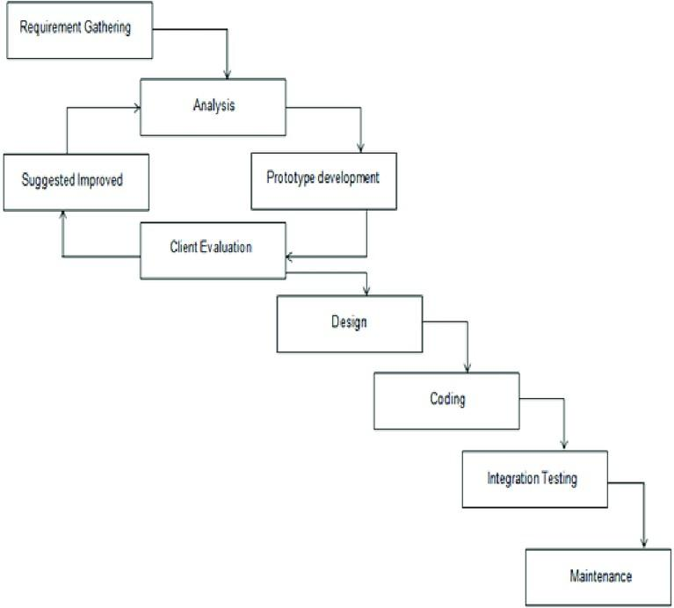

Fig.1.1. Evolutionary Prototyping Model [2]

The figure above represents the stages of evolutionary prototyping model. It begins with requirement gathering to understand what is needed. These requirements are then analyzed to determine feasibility and how they should be implemented. Based on this analysis, an initial prototype is developed. The client evaluates this prototype, providing feedback on its performance and features. Suggestions for improvement are collected during this evaluation phase and are fed back into the prototype development, signifying an iterative process. Improvements are made, and the prototype is refined over multiple iterations, continually involving client feedback until it meets the client’s expectations. Once the prototype is sufficiently evolved, the design phase formalizes the structure of the final product. The design is then transformed into a working system through the coding stage. After coding, integration testing ensures all parts of the software work together correctly. Finally, the software enters the maintenance stage, where it is updated and fine-tuned while being in use to accommodate any additional requirements or changes that arise over time.

Report Organization

Chapter 1 provides an overview of the project, introducing its significance and addressing the identified problem. The chapter outlines the objectives, defines the scope and limitations, presents the chosen development methodology, and provides an overview of the report organization.
In Chapter 2, the background study includes fundamental theories, concepts, and terminologies related to the project. The literature review offers a comprehensive overview of similar or relevant projects, theories, and findings by other researchers, establishing a context for the project.
Chapter 3 focuses on system analysis, exploring in-depth requirements through functional and non-functional aspects. It includes a feasibility analysis covering technical, operational, economic, and schedule aspects. The use of an object-oriented approach, ER diagrams, and modeling techniques like class and activity diagrams are detailed in the analysis section.
Chapter 4 moves to the design phase, presenting the transformation of ER diagrams to relations and normalization processes. The chapter also discusses user interface design and provides detailed insights into the algorithmic aspects of the project.
Chapter 5 includes the practical aspects of the project. It describes the tools used in the implementation phase, including CASE tools, programming languages, and database platforms. The chapter provides implementation details for modules, classes, procedures, functions, methods, and algorithms. Testing is covered extensively, with details on unit testing, system testing, and result analysis.
The final chapter, Chapter 6, draws conclusions based on the findings and outcomes of the project. It also outlines potential future recommendations for further enhancements or expansions of the project, bringing the report to a comprehensive close.

CHAPTER 2:

BACKGROUND STUDY AND LITERATURE REVIEW

Background Study

After conducting extensive research on electronic and blockchain-based voting systems, it has been observed that the integration of blockchain technology in elections is becoming a promising approach to enhance transparency, security, and trust in the voting process. Traditional voting systems, whether paper-based or electronic, often face challenges such as vote tampering, lack of transparency, limited accessibility, and inefficiency in vote counting. These problems have encouraged researchers and developers to explore blockchain as a means to secure and decentralize election processes.
According to Swan (2015), blockchain provides an immutable and transparent ledger that ensures each transaction (or vote) is recorded permanently and cannot be altered once validated. This characteristic makes blockchain technology suitable for applications that demand high security and data integrity, such as voting systems. Similarly, Shahzad et al. (2019) highlighted that blockchain-based voting enhances voter confidence by allowing verifiable yet anonymous participation, eliminating the need for centralized authorities to control or manipulate election data.
In the context of Nepal, where digital transformation is steadily progressing, a blockchain-based voting platform can contribute to a more trustworthy and efficient electoral process. Current voting procedures in Nepal still rely heavily on manual paper ballots, which can be prone to delays, human errors, and fraudulent activities. Implementing a decentralized voting system such as TrueVote can help address these limitations by providing a transparent, secure, and verifiable digital voting experience that is suitable even for remote or marginalized voters.
A study by Ayed (2017) emphasized that decentralized ledger technologies reduce single points of failure, making voting systems more resilient to attacks or manipulation. In a custom voting network, this can be achieved through distributed block validation, signature checks, and persistent storage of confirmed votes.

Literature Review

Several studies have examined the feasibility, benefits, and challenges of implementing blockchain-based voting systems.
Zheng et al. (2017) described blockchain as a distributed and tamper-proof data structure that maintains integrity through cryptographic techniques and consensus mechanisms. These properties make blockchain suitable for secure and transparent elections, while one-vote-per-election rules can be enforced directly by the node.
In a study conducted by Hjalmarsson et al. (2020), it was found that blockchain voting improves auditability by allowing independent verification of results without compromising voter anonymity. This form of verifiable transparency strengthens trust among participants and stakeholders in the electoral process. Another study by Hardwick et al. (2018) suggested that blockchain voting can increase voter participation by offering accessibility through digital platforms, making it especially beneficial for citizens living abroad or in remote areas.
Within the South Asian context, researchers have recognized the potential of blockchain technology in strengthening democratic systems. A study by Prakash and Gurung (2021) proposed that Nepal could benefit from a hybrid e-governance framework using blockchain to ensure transparent decision-making and public accountability. Such frameworks can be extended to electoral systems like TrueVote to enhance legitimacy and reduce administrative burdens.
Overall, literature suggests that blockchain voting systems, when properly implemented, can revolutionize traditional electoral processes by offering security, transparency, anonymity, and accessibility. However, challenges such as digital literacy, scalability, and regulatory readiness remain key considerations for successful adoption in developing nations like Nepal.

Study of existing systems

An in-depth analysis of traditional and electronic voting systems was conducted to understand their strengths and limitations.
- Paper-based Voting Systems: These are commonly used but suffer from logistical constraints, high administrative costs, susceptibility to human error, and limited accessibility for remote or disabled voters.
- Electronic Voting Machines (EVMs): While they streamline vote counting and reduce ballot paper usage, EVMs rely on centralized databases and closed hardware, making them vulnerable to manipulation, software bugs, and hacking.
- Online Voting Portals: Many modern online voting portals are built on centralized infrastructure. They often lack voter-verifiable audit trails and are not equipped to prevent double voting, impersonation, or denial-of-service attacks.
This study highlighted the urgent need for a secure, decentralized, and transparent system that ensures verifiability, voter privacy, and accessibility — especially for absentee or disabled voters.

CHAPTER 3: SYSTEM ANALYSIS

System Analysis

Here, the focus is on understanding and defining the system's requirements and feasibility. The section describes the functional requirements through the illustration of use case diagrams, portraying user-system interactions. Non-functional requirements, encompassing aspects like performance and security, are also explored. Additionally, the feasibility analysis examines the technical, operational, economic, and scheduling aspects of the project. The chapter employs an object-oriented approach, utilizing tools such as class diagrams for object modeling, and activity diagrams for process modeling, to comprehensively analyze and design the system.

Requirement Analysis

The following are the functional and non-functional requirements of the system:

Functional Requirements:

User Roles:

Voters / User:
• User Registration and Authentication
Voters must be able to securely register and verify their identity using OTP, biometric verification, or blockchain wallet authentication.
• Voter Eligibility Verification
Voters must be validated against the authorized voter list before gaining access to the voting interface.
• Vote Casting
Registered voters should be able to securely cast their votes through a simple, intuitive interface.
• System Notifications
Voters should receive confirmation messages upon successful vote submission and updates related to the election process.
• Audit and Verification (User Perspective)
Voters should have the ability to verify that their votes were counted correctly without revealing their identity.

Admin:
• Administrative Controls
Administrators should be able to configure new elections, define start and end times, manage voter lists, and oversee the overall voting process.
• Voter Eligibility Management
Admins must ensure that the voter database is accurate and authorized, maintaining data integrity before elections begin.
• Election Monitoring
Administrators should be able to monitor real-time participation rates, vote submission statistics, and detect potential anomalies.
• Result Publishing
After voting concludes, administrators must publish the final results transparently for public access and verification.

System Roles:
• Vote Encryption and Recording
The system must automatically encrypt each vote and record it immutably on the blockchain to prevent alteration or tampering.
• Prevention of Double Voting
The system must enforce a one-vote-per-voter rule by automatically detecting and blocking duplicate submissions.
Real-Time Vote Tallying
The system should automatically tally votes from confirmed blocks, ensuring accuracy and transparency.
Notifications and Communication:

- Notifications: Receive notifications for registration status, vote acceptance, mining completion, and election results.
- Communication: Communicate with the admin/support through the messaging system for queries and support.

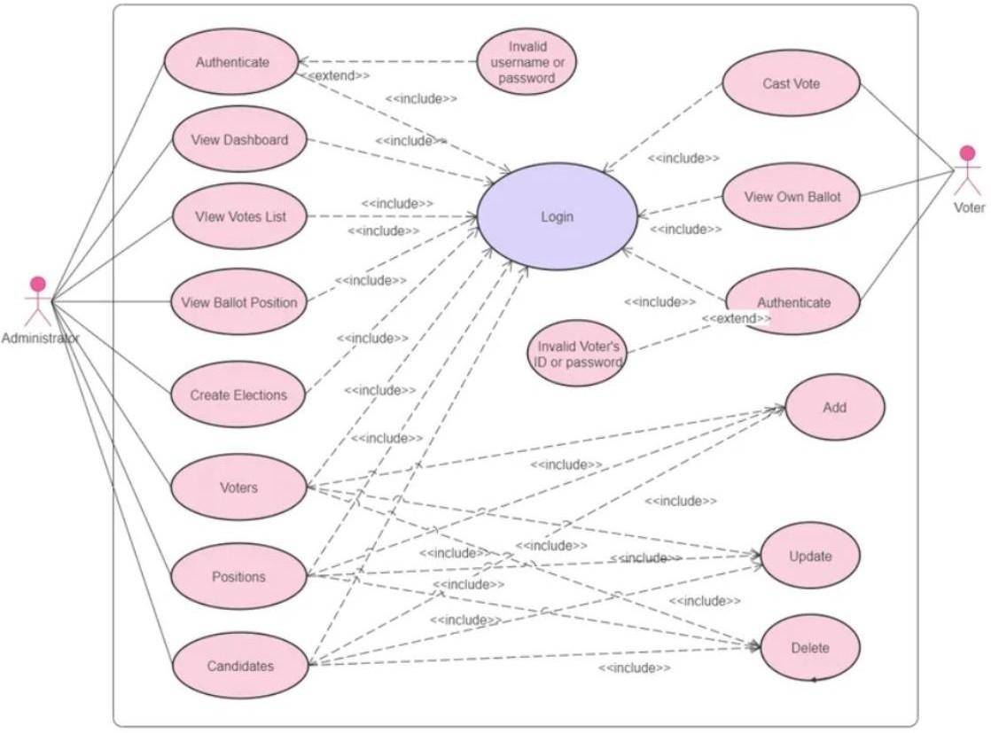

Fig.3.1. Use case Diagram

The above use case diagram represents the functionality of our project from the perspective of three actors: Voter, Admin, and System. The Voter can create a wallet, register, and cast signed votes. The Admin can create elections, manage candidates, and monitor results. The System verifies signatures, rejects duplicates, stores pending votes, mines blocks, and tallies results.
Use Case Description:

Table 3.1 :Voter Registration Use Case Description

Use case ID: 01
Use Case Name | Voter Registration
Scenario | Register a new voter account for participation in elections
Triggering event | User selects the “Register” option.
Brief description | The voter should be able to create a secure account by providing personal details, biometric, or blockchain wallet authentication. Once verified, the voter is added to the system as an eligible participant.
Actors | Voter
Related use cases | None
Stakeholders | Voter, Election Administrator, Election Commission
Preconditions | The user must have valid identity credentials for verification.
Postconditions | New voter account is created
Flow of Activities | - The voter navigates to the registration page.  - The system displays the registration form.  - The voter enters personal and verification details (OTP/biometric/wallet).  - The system validates the provided information.  - Upon successful verification, a new voter account is created.
Exception conditions | - If the voter provides incomplete or invalid details, the system displays an appropriate error message.  - If verification fails, registration is denied and promted to try again.

Table 3.2 :Cast Vote Use Case Description

Use case ID: 02
Use Case Name | Cast Vote
Scenario | Voter securely casts their vote during an active election
Triggering event | The authenticated voter selects an ongoing election and chooses to cast their vote
Brief description | The voter should be able to securely select a candidate or option and submit their vote through the TrueVote platform.
Actors | Voter
Related use cases | UC-01 (Voter Registration)
Stakeholders | Voter, Election Administrator
Preconditions | - The voter must be logged in and verified.  - The election must be active.  - The voter must not have voted already.
Postconditions | The vote is encrypted, recorded on the blockchain, and counted toward the election tally and voter receives confirmation message.
Flow of Activities | • Voter logs into the TrueVote platform.  • Voter navigates to the active election page.  • System displays the list of candidates/options.  • Voter selects their preferred choice and confirms submission.  • System encrypts and records the vote on the blockchain.  • Confirmation message is displayed to the voter.
Exception conditions | • If the voter has already voted, the system denies further submissions.  • If a network or blockchain error occurs, the system notifies the voter and allows retry after stability.

Non-Functional Requirements:

1. Security
The system must ensure the protection of all user data and votes from unauthorized access, manipulation, or cyberattacks. This includes implementing strong encryption standards, secure authentication methods, and blockchain-based immutability to guarantee data integrity and election transparency.

2. Usability
TRUE VOTE should provide a simple, intuitive, and accessible user interface that accommodates voters of all technical backgrounds. The design must minimize errors, include clear instructions, and ensure that the voting process can be completed efficiently and confidently.

3. Reliability
The platform must remain consistently operational and stable throughout the election period. It should handle unexpected failures gracefully, recover quickly from disruptions, and maintain service availability to ensure uninterrupted voting sessions.

4. Privacy
Voter anonymity must be strictly maintained. The system should prevent any association between a voter’s identity and their cast vote, ensuring confidentiality at every stage of the election process. Privacy-preserving cryptographic techniques should be integrated to support this requirement.

5. Performance
TRUE VOTE should deliver fast response times and maintain high throughput, even under peak voting conditions with a large number of concurrent users. The system’s performance must scale efficiently to support national or regional election sizes without delays or degradation in user experience.

Feasibility Analysis

Feasibility analysis is the first step in designing any project. It involves gathering information to determine whether a project is possible or not. The study compares the estimated costs with available resources and conducts a cost-benefit analysis of the system. The main objective of a feasibility study is to determine whether the project would be feasible in terms of economic, legal, technical, and operational feasibility or not.

Technical Feasibility:
TrueVote will use a custom FastAPI backend, a React frontend, Ed25519 signature utilities, JSON file persistence, and a local Proof-of-Work blockchain. These tools keep the system lightweight, fully custom, and independent of third-party wallet and contract tooling.

Economic Feasibility:

The system will be built using the tools that are freely available on the internet as well as royalty free images, so, this system is economically feasible. Also Developing TrueVote as a blockchain-based digital voting platform can reduce the costs associated with traditional paper-based elections, such as printing ballots and manual counting.

Table 3.3: Cost Analysis

Cost | Amount(Rs.)
Frontend Development | 15000
Backend Development | 15000
Database Design | 10000
UI/UX Design | 10000
Internet and Scurity | 5000
Deployment (Domain and Hosting) | 3000
Total | 58,000

Legal Feasibility:

Legal feasibility refers to the evaluation of whether a software project can be implemented successfully based on legal and ethical requirements. It involves analyzing the barriers to legal implementation of the project, data protection or social media laws, project certificates, licenses, copyrights, etc. The project that we are developing is legally feasible as it does not break any legal rules.

Operational Feasibility:

Since the proposed system can be accessed using a web browser which is available in both desktop computers as well as mobile devices, thus, it is operationally feasible. The system is designed to be user-friendly for voters with minimal technical knowledge. Voting can be done remotely, increasing accessibility and convenience.
Performance - Our site can handle a large number of events such as voting .

Information - The platform provides voters with essential information about ongoing elections, including candidate details, election schedules, and voting procedures.
Economy - Developing and maintaining the site and its operations are cost effective as it is built in js, and js is easy to debug and maintain.
Control - The site ensures that user data is secure, maintaining privacy of both voters and candidates , and providing different levels of access to admin and users.
Efficiency- The overall system is lightweight, enabling fast vote submission, verification, and result tallying without unnecessary external blockchain dependencies.
Services - The site provides all the services that are needed in a voting application and improves the overall user experience.

Schedule Feasibility:

Schedule feasibility is a type of feasibility study that assesses whether a project can be completed within a given timeframe. It examines the time required to complete each task and determines whether it is feasible to complete the project within the given schedule. To assess schedule feasibility, project managers use various tools such as Gantt charts, PERT charts, and the Critical Path Method (CPM). For our project, we are using Gantt Chart. Given below is a Gantt Chart describing the schedule for the project :

Process | No. of Weeks
 | 1 | 2 | 3 | 4 | 5 | 6 | 7 | 8 | 9 | 10
Requirement
Gathering
Planning
Designing
Coding
Testing and
debugging
Implementation

Fig.3.2. Gantt chart of work schedule

This Gantt chart provides a visual work schedule for our project spanning from October to March. The Gantt chart outlines the planned timeline for the development of the TrueVote application over a 10-week period. The project begins with requirement gathering in the first week, followed by planning in weeks 2 and 3 to define system scope and design specifications. Designing of the user interface and system architecture occurs during weeks 4 and 5. Coding or actual development of the application is scheduled for weeks 6 through 8, while testing and debugging are planned for weeks 8 and 9 to ensure functionality, security, and reliability. Finally, implementation and deployment of the system are set for week 10, marking the completion of the project and readiness for user access.

Analysis and Diagram

Class Diagram

A class diagram is a specific kind of UML (Unified Modeling Language) diagram that is used to show how a system or software application is organized.
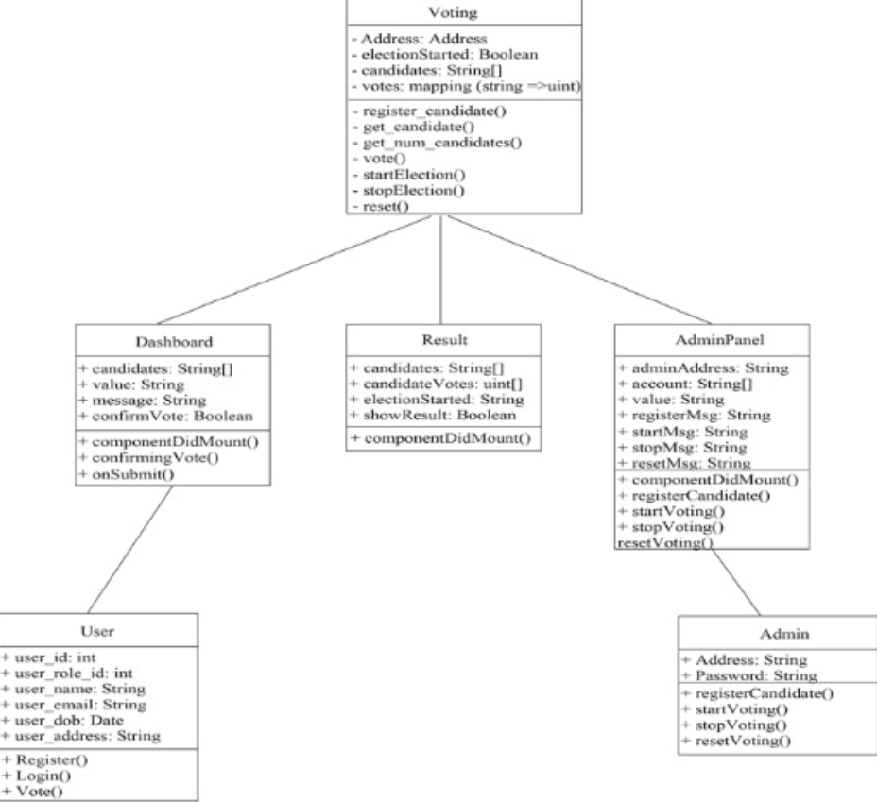

fig.3.4. Class Diagram
The class diagram for TrueVote represents the core structure of the system, showing how different components interact to enable secure and transparent voting. It includes classes such as Admin, responsible for managing elections and candidates; Voter, which handles user registration, authentication, and vote casting; Election, which stores election details; Candidate, representing participants; and Vote, which securely records each ballot. The relationships between these classes ensure data integrity, streamline processes, and maintain a clear flow of information across the system.

CHAPTER 4: SYSTEM DESIGN

Design

System Architecture Diagram

System architecture design refers to the conceptual model that defines the structure, behavior, and more views of a system. It is a blueprint for the system and the development project, laying out the tasks necessary to be executed by the design teams.

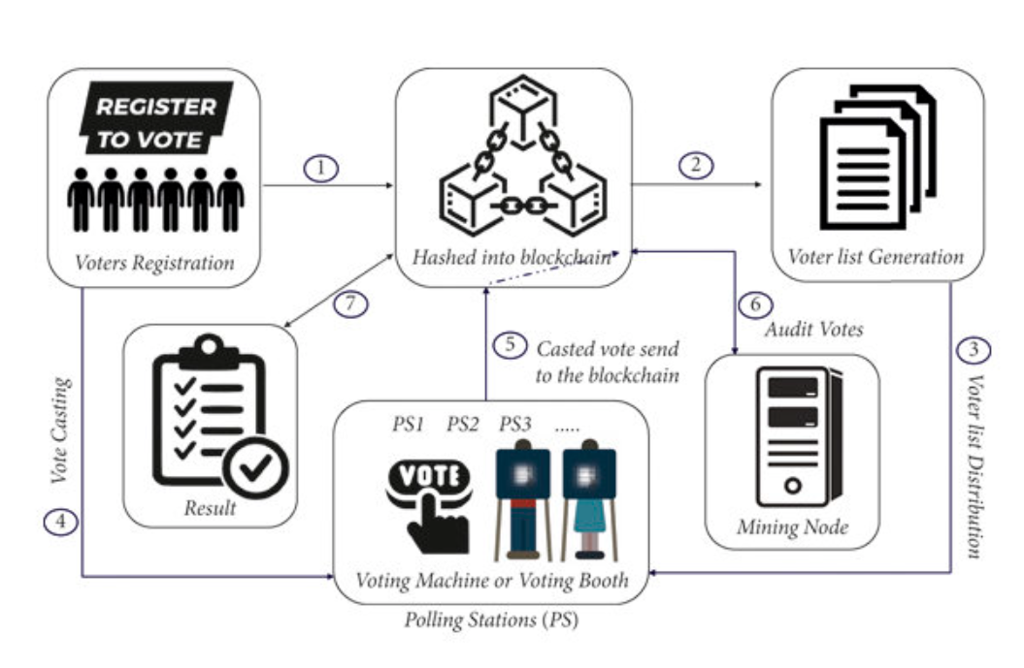

FIG 4.1: Repository System Architecture Design

The figure above illustrates the system design architecture of TrueVote, showcasing the interaction between voters, administrators, and the secure backend system. Administrators oversee the entire election process, including creating elections, managing candidates, and monitoring system activities. Voters begin by registering and authenticating their identities, after which they can securely cast their votes through the user interface. The Authentication Module verifies user credentials to ensure legitimacy, while the Voting Module records and encrypts each vote before storing it on the Blockchain Network, ensuring transparency and immutability. The Database manages general user and election data, whereas the Blockchain Ledger securely stores all voting records.

Component Diagram

A component diagram is a type of Unified Modeling Language (UML) diagram that depicts the high-level structure of a system, showcasing the components that make up the system and their relationships.

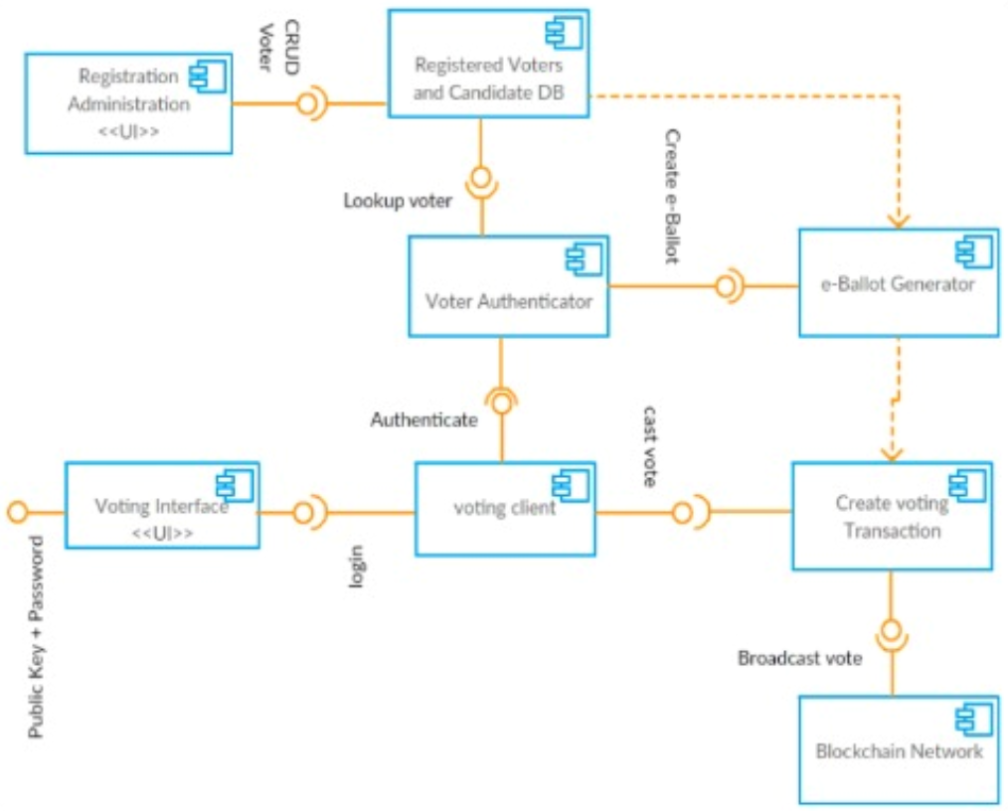

fig 4.2: Component diagram

The component diagram for TrueVote illustrates the system’s overall structure and interaction between key modules. Major components include the User Interface for voter and admin interactions, the Authentication module for secure user verification, and the Voting Management component for handling election setup and vote casting. The Blockchain component ensures transparency, immutability, and secure storage of votes, while the Validation Engine enforces voting rules and duplicate checks. The Database stores general system data, and communication between components is handled through the Application Server, maintaining a clear separation of concerns.

Algorithm Details

For our project, we have used blockchain-based security algorithms. These algorithms form the core of decentralized systems and are designed to ensure transparency, security, and trust among participants without relying on a central authority. In particular, we have implemented Ed25519 signature verification and the SHA-256 hashing algorithm. Ed25519 is used to authenticate vote messages, while SHA-256 ensures the integrity and immutability of stored votes. Together, these algorithms guarantee that every vote cast through TrueVote remains secure, verifiable, and tamper-proof while maintaining voter anonymity and trust in the election process.

4.2.1. Consensus Algorithms
Consensus algorithms are at the heart of blockchain. They ensure that all participants (nodes) agree on the validity of transactions (votes) before they are recorded.

a) Proof of Work (PoW)
- Used In: Bitcoin and custom Proof-of-Work blockchain networks
- Purpose: Requires nodes to solve complex mathematical puzzles to validate transactions.
- Relevance: Ensures that adding a vote block to the blockchain is computationally expensive, deterring malicious tampering.
- Limitation: High energy consumption makes it less ideal for real-time voting.

b) Proof of Stake (PoS)
- Used In: Some modern blockchain networks
- Purpose: Validators are chosen based on the amount of cryptocurrency they “stake” rather than solving puzzles.
- Relevance: Not used in TrueVote; the project uses Proof of Work for a simpler private voting network.
- Benefit: Lower implementation complexity for an academic voting system.

4.2.2. Cryptographic Algorithms
These algorithms secure data and ensure voter privacy, authentication, and vote integrity.

a) SHA-256 (Secure Hash Algorithm 256-bit)
- Purpose: Converts vote data into a unique, irreversible hash.
- Used For: Vote encryption and integrity verification.
- Relevance: Ensures each vote remains tamper-proof and traceable without revealing voter identity.

b) RSA (Rivest–Shamir–Adleman)
- Purpose: Asymmetric encryption algorithm using a public and private key pair.
- Relevance: Can be used for voter authentication and secure data exchange.
- Benefit: Prevents unauthorized vote access or forgery.

4.2.3. Digital Signature Algorithms
Used to verify authenticity and integrity of transactions (votes).

a) ECDSA (Elliptic Curve Digital Signature Algorithm)
- Purpose: Ensures that only legitimate voters can cast votes and that the vote hasn’t been altered.
- Relevance: Widely used in blockchain systems for authentication and non-repudiation.
- Benefit: Provides authentication and non-repudiation.
4.3 Implemented Algorithms
The following algorithms form the core of the TrueVote voting system, organized by execution phase:
4.3.1 Vote Authentication and Canonicalization
A vote is authenticated using Ed25519 digital signatures. Before signing, the vote is serialized in canonical form: voter_id, candidate_id, and election_id are combined in fixed order and UTF-8 encoded. This ensures deterministic hashing and prevents tampering. The voter signs this canonical byte sequence locally with their private key; the server verifies using the corresponding public key.
Key Properties:
- Deterministic: identical votes always produce identical signatures
- Non-repudiation: voter cannot deny having signed
- Forgery-resistant: attacker cannot sign without the private key
- Replay-resistant: different election_ids produce different signatures
4.3.2 Duplicate Prevention via Persistent Vote Registry
The node maintains a persistent registry of (voter_id, election_id) pairs for all accepted votes. Before accepting a new vote, the server checks this registry. If the pair exists, the vote is rejected immediately; otherwise, it proceeds to the verification step.
Mechanism:
1. Receive vote with voter_id and election_id
2. Query persistent registry for prior vote with same pair
3. If found, reject; if not found, proceed to Ed25519 verification
4. On successful verification, add pair to registry
Persistence: Stored in JSON so the rule survives restarts and applies consistently.
4.3.3 Mining and Block Creation via Proof-of-Work
Pending verified votes are assembled into a block. The miner searches for a nonce value such that SHA256(block_header || nonce) satisfies the difficulty target (e.g., N leading zero bits).
Algorithm:
1. Collect verified votes with timestamp and previous_hash
2. For nonce = 0, 1, 2, ... until success:
- Compute block_hash = SHA256(header || nonce)
- If leading_zeros(block_hash) >= DIFFICULTY, stop
3. Return Block(header, nonce, votes)
The DIFFICULTY parameter adjusts average mining time. Higher difficulty = more computational work = stronger proof of block creation.
4.3.4 Block Validation and Consensus
When a block is received from a peer, the node validates:
- Proof-of-work: verify hash satisfies difficulty target
- Vote signatures: re-verify Ed25519 signatures of all votes in block
- No double-votes: confirm no (voter_id, election_id) pair appears twice (within block and against chain history)
- Chain linkage: previous_hash must match the parent block
Consensus Rule: In case of competing chains, the longest valid chain is authoritative. A node adopts a longer chain if all blocks validate correctly.
4.3.5 Persistence and Recovery
The full blockchain state, voter registry, and pending votes are serialized to JSON files. On startup, the node loads and validates all data:
Files:
- blockchain_data.json: full block history
- voter_registry: voter_id → public_key mapping
- pending_votes: votes awaiting mining
Recovery Steps:
1. Load JSON data
2. Verify chain integrity (each block links correctly to predecessor)
3. Validate all block signatures and PoW conditions
4. Resume operation if valid; restart with empty state if corrupted
4.3.6 Peer Synchronization and Network Consensus
After mining or receiving a valid block, the node broadcasts to registered peers. Each peer validates the block and, if valid, appends it to its local chain and re-broadcasts.
Synchronization: If a node detects it is behind (fewer blocks), it requests a full chain sync from a peer and reconciles by adopting the longest valid chain.
This ensures all nodes converge on the same canonical chain state.

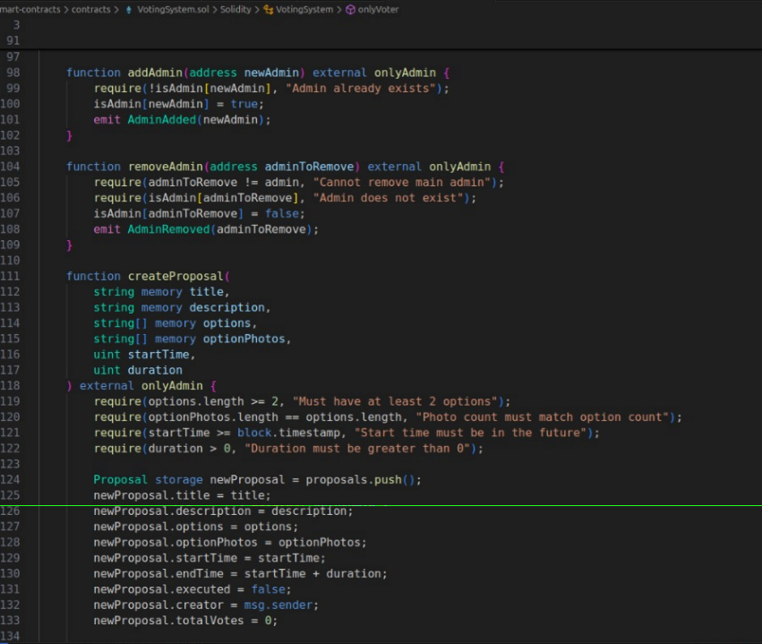

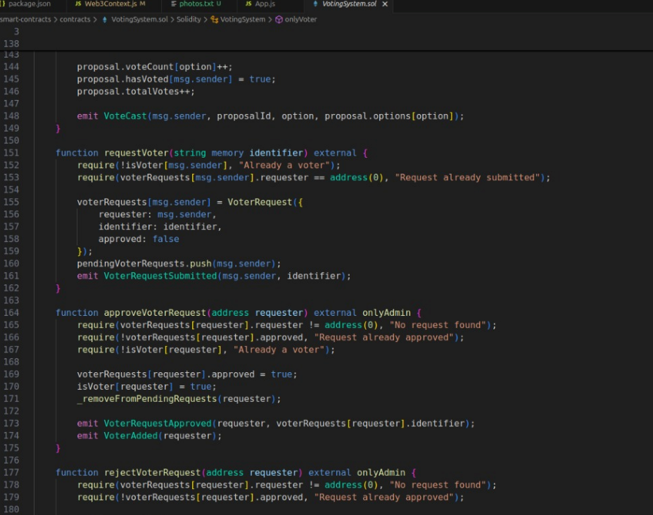

CHAPTER 5: IMPLEMENTATION AND TESTING

Implementation

Tools Used

i) Programming Language Front End
• ReactJS: React is a popular JavaScript library for building dynamic and responsive user interfaces. It allows the creation of reusable UI components and enables fast rendering through its virtual DOM, enhancing performance and scalability.
• HTML5: HTML5 provides the structure of the web application, supporting semantic tags, multimedia elements, and better accessibility for a rich and modern interface.
• CSS3: CSS3 is used to style the components, making the interface visually appealing, responsive, and user-friendly. It ensures consistent design across all screen sizes and devices.
• JavaScript: JavaScript adds interactivity and dynamic behavior to the web application. It helps in handling user inputs, event-driven actions, and seamless communication with backend services.
• Custom CSS: A dedicated stylesheet is used to create the responsive voting dashboard interface without external UI frameworks.

Backend
• Python / FastAPI: Python powers the backend API, vote verification, mining, and persistence logic.
• FastAPI/Uvicorn: The backend server handles requests, vote verification, blockchain updates, and peer communication.
• Cryptography utilities: Local signing and verification are handled with Ed25519 and base64 encoding rather than Web3 libraries.

Blockchain Platforms

Custom blockchain network: TrueVote uses a local Proof-of-Work blockchain and JSON persistence for vote storage.

Authentication

Local wallet storage: Users keep their private key locally in the browser or CLI, and only the public key is registered with the node.

Project Management Tool

Trello: It is a popular web-based application that utilizes boards, lists, and cards to help individuals and teams organize and manage projects. Trello uses a visual system where users can create boards for different projects, and within each board, they can create lists to represent different stages or categories. Cards within lists represent tasks, ideas, or items that need attention.

Configuration Management Tool

GitHub: GitHub is a popular version control system used in software configuration management. It provides a hosting platform for Git repositories, allowing us to store and manage the source code. It keeps track of changes made to the codebase over time, allowing us to view the entire version history of a project.

Drawing Tool

Draw.io: Draw.io, now known as diagrams.net, is a free and versatile online diagramming tool that allows users to create a wide range of diagrams, flowcharts, and other visual representations. It supports collaborative editing, integration with various cloud platforms, and provides an intuitive interface for creating and customizing diagrams. We used it for drawing use cases, activity and class diagrams.

5.2 Testing

Software testing is a process of evaluating software to find defects and ensure that it meets the requirements specified by the customer. It is an important part of the software development process and helps to ensure that the software meets the needs of the users.

5.2.1 Test Cases For Login and Account Creation Test Case 1: Admin Login
Table 5.1: Test case for Admin Login

S.N | Test Inputs | Expected Output | Actual Output | Result
1 | Valid Admin Login (Email and password or Metamask Connection) | Login success | Login success and redirected to Dashboard | Test Successful
2 | Invalid Admin login information:test123@gmail  .com | Login unsuccessful | Account not found. Please contact the administrator | Test Successful
3 | Empty Username/Email & Password: | Login unsuccessful | Invalid Username and Password | Test Successful

Test Case 2: Voters Login

Table 5.2: Test case for Voters Login

S.N | Test Inputs | Expected Output | Actual Output | Result
1 | Valid credentials (Email + Password or MetaMask login) | Login success | Redirect to User Dashboard | Test Successful
2 | Empty Username/Email and Password: | Login unsuccessful | Invalid Username and Password | Test Successful
3 | Valid Username/Email and Invalid Password) | Login unsuccessful | Incorrect Password Please try again | Test Successful
4 | MetaMask wallet not connected | Login unsuccessful | Account not found. Please contact the administrator | Test Successful

Test Case 3: Cast Vote

Table 5.3: Test case for Cast Vote

S.N | Test Inputs | Expected Output | Actual Output | Result
1 | Select candidate and submit vote | Vote Recorded successful. | Vote Recorded and Confirmation Message Displayed | Test Successful
2 | Attempt to vote twice | Vote Unsuccessful | Error: You have already voted | Test Successful
3 | Submit without selecting candidate | Vote unsuccessful. | Error: Please select a candidate before submitting | Test Successful

Test Cases For Functional Testing

Functional testing is a type of software testing that verifies the functionality of a software application. It ensures that the application meets the requirements specified in the functional specification. Functional testing can be done manually or automatically. Manual functional testing is done by testers who interact with the application and test its features. Automatic functional testing is done using tools that automate the testing process. Here we performed manual functional testing.
Test Case 1: Cast Vote

Table 5.4: Test case for Voter Registration

S.N | Test Inputs | Expected Output | Actual Output | Result
1 | Submit registration form with all valid details | Registration Successful | Registration Successful, Redirect to Login Page | Test Successful
2 | Submit registration form with missing fields | Registration Unsuccessful | Error: Please fill all mandatory fields | Test Successful
3 | Submit registration with invalid email format | Registration Unsuccessful | Error: Invalid Email Format | Test Successful
4 | Submit registration with existing email | Registration Unsuccessful | Error: Email already registered | Test Successful

Test Case 2: End To End WorkFlow

Table 5.5: Test case for End to End WorkFlow

S.N | Test Inputs | Expected Output | Actual Output | Result
1 | Simulate complete user workflow | Successful completion of registration, login, vote casting, and result viewing | Registration Successful, Login Successful, Vote Recorded, Result Displayed | Test Successful

5.3 Result Analysis

The results demonstrate that the TrueVote system is highly effective in managing both admin and voter interactions with security, accuracy, and reliability. The authentication and voting functionalities performed as expected, ensuring that only verified users could cast their votes while maintaining the privacy and anonymity of each voter. The system successfully prevented duplicate voting attempts and handled invalid or incomplete inputs with clear, user-friendly error messages.
Administrative features, including election creation, voter registration, and result management, functioned smoothly and efficiently. Each operation reflected accurate data storage and retrieval through blockchain transactions, confirming the integrity of the system’s decentralized architecture.
All test cases marked as “Test Successful” validate that the system behaves according to its design specifications and functional requirements. The testing phase covered a range of user scenarios, including login validation, vote submission, and result verification, ensuring the platform’s resilience under various conditions.
Overall, the test outcomes indicate that TrueVote is a secure, transparent, and reliable platform capable of supporting real-world voting processes. The system’s performance highlights its readiness for deployment and its potential to redefine electronic voting by ensuring fairness, eliminating manipulation, and enhancing public trust in the electoral process.

CHAPTER 6:

CONCLUSION AND FUTURE RECOMMENDATIONS

Conclusion

In concluding this project, we have successfully developed a secure, transparent, and user-friendly blockchain-based voting system — TrueVote — that redefines the way elections can be conducted in a digital era. The project has been a remarkable journey marked by innovation, collaboration, and continuous learning. Through meticulous design, analysis, and implementation, we have applied our technical and problem-solving skills to create a reliable voting platform that ensures integrity, anonymity, and trust.
The use of blockchain technology has been pivotal in achieving transparency and tamper-proof data storage, while the incorporation of cryptographic techniques has ensured that every vote remains secure and verifiable. The development process followed systematic software engineering principles, supported by diagrams such as ER models, use case diagrams, and class diagrams, which helped in maintaining structural clarity and system coherence.
Collaboration tools such as GitHub and Trello played a vital role in coordinating our workflow, enabling efficient version control and seamless teamwork throughout the project. Each phase of development strengthened our understanding of decentralized technologies, security protocols, and project management practices.
As we conclude, we carry forward not only a functioning prototype of TrueVote but also invaluable knowledge and experience gained throughout its creation. This journey has deepened our understanding of blockchain application development and the importance of designing secure, user-centric systems. These insights will undoubtedly guide our future endeavors, empowering us to approach new challenges with greater innovation, confidence, and vision.

Future Recommendation

In the next phase of development, we aim to enhance TrueVote by improving system scalability, user experience, and accessibility. Future versions of the platform could include support for multi-chain integration to ensure faster and more cost-effective transactions, reducing dependence on a single blockchain network. We also plan to implement Zero-Knowledge Proofs (ZKPs) or Homomorphic Encryption to strengthen voter anonymity while allowing verifiable vote audits without revealing individual choices.
To make the platform more user-friendly and inclusive, a mobile voting application can be developed, allowing citizens to participate securely from their smartphones using biometric verification or national ID integration. Incorporating real-time analytics and reporting tools will help election administrators monitor participation rates and system performance more effectively.
Collaboration with national authorities such as the Election Commission of Nepal will be explored to align TrueVote with existing electoral policies and regulations. Additionally, continuous testing, security audits, and feedback-driven improvements will be carried out to ensure reliability and public trust.
Finally, promotional efforts, pilot programs, and educational campaigns could be launched to raise awareness of blockchain voting among the public. With these enhancements, TrueVote can evolve into a fully decentralized, transparent, and secure voting solution capable of transforming the future of democratic participation in Nepal.

References

[1] S. Nakamoto, "Bitcoin: A Peer-to-Peer Electronic Cash System," 2008.
[2] M. Crosby, P. Pattanayak, S. Verma and V. Kalyanaraman, "Blockchain technology: Beyond bitcoin," Applied Innovation Review, vol. 2, pp. 6–10, 2016.
[3] Investopedia, "Elliptic Curve Cryptography (ECC)," investopedia.com, [Online]. Available: https://www.investopedia.com/terms/e/ecc.asp. [Accessed 17 05 2025].
[4] TutorialsPoint, "Merkle Tree in Blockchain," tutorialspoint.com, [Online]. Available: https://www.tutorialspoint.com/blockchain/blockchain_merkle_tree.htm. [Accessed 17 05 2025].
[5] PyCA Cryptography, "Ed25519 - Asymmetric signatures," https://cryptography.io/en/latest/hazmat/primitives/asymmetric/ed25519/.
[6] N. Kshetri, "Blockchain’s roles in strengthening cybersecurity and protecting privacy," Telecommunications Policy, vol. 41, no. 10, pp. 1027-1038, 2017.
[7] IBM Blockchain, "Blockchain for Voting," ibm.com, [Online]. Available: https://www.ibm.com/blockchain/industries/government. [Accessed 17 05 2025].

Appendix

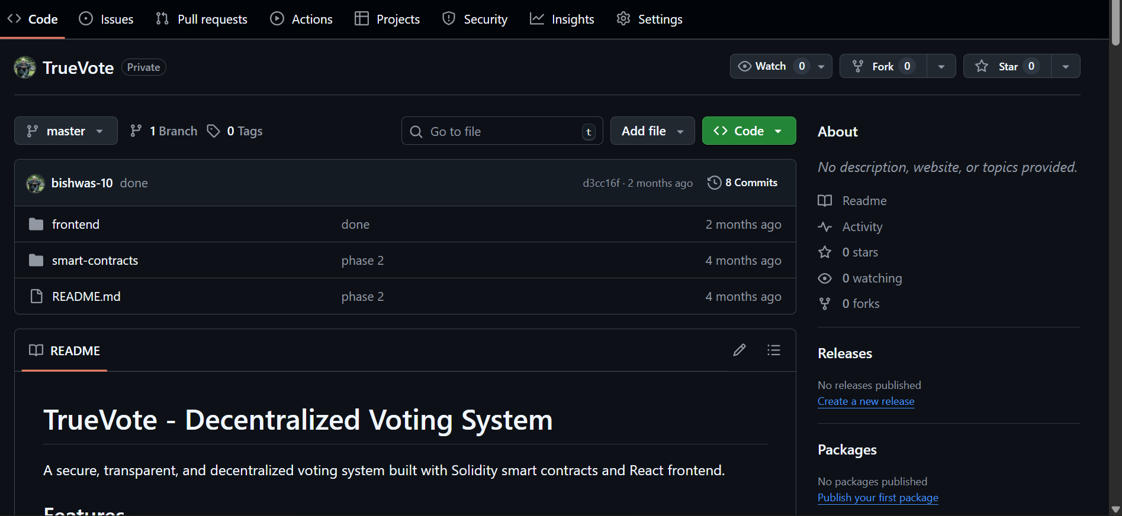

Screenshot of Github Repository
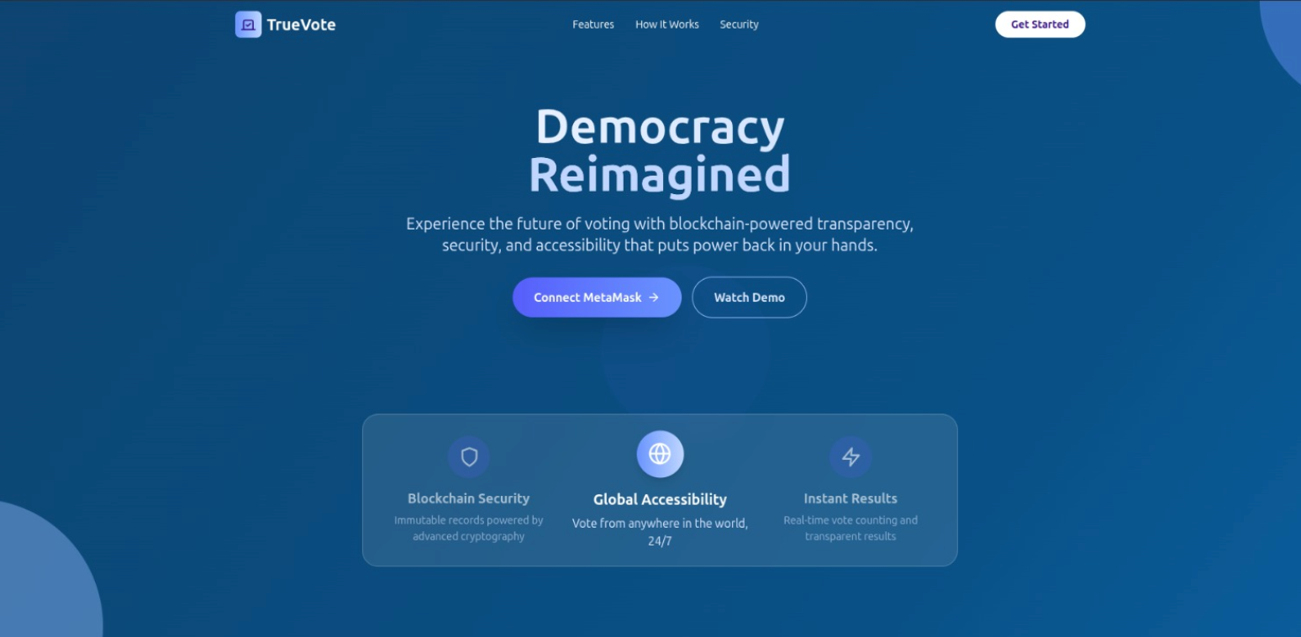

Screenshot of Home Page

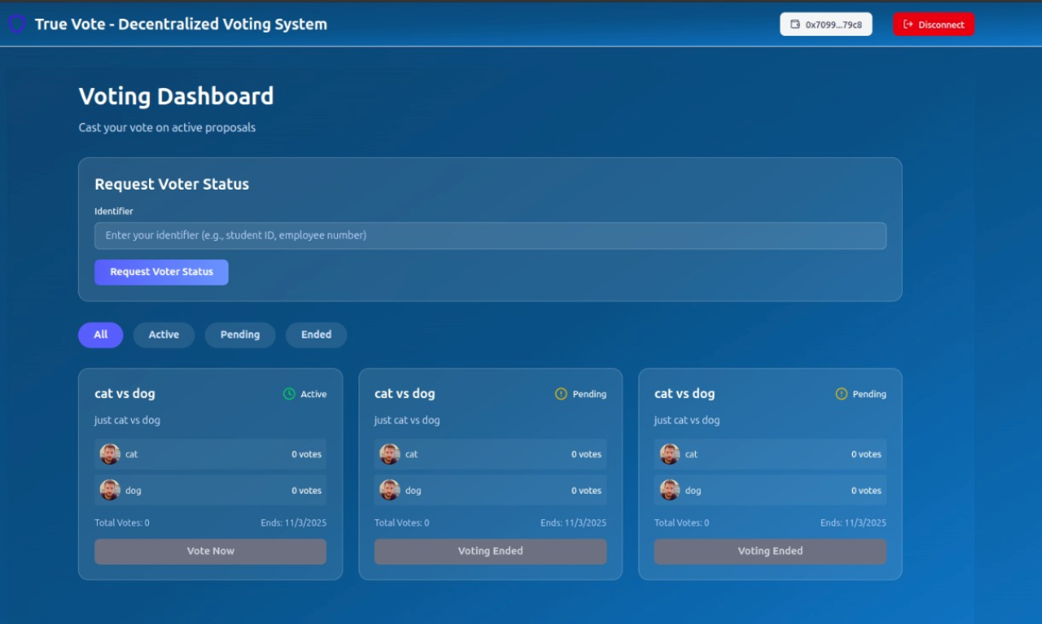

Screenshot of Voters Dashboard
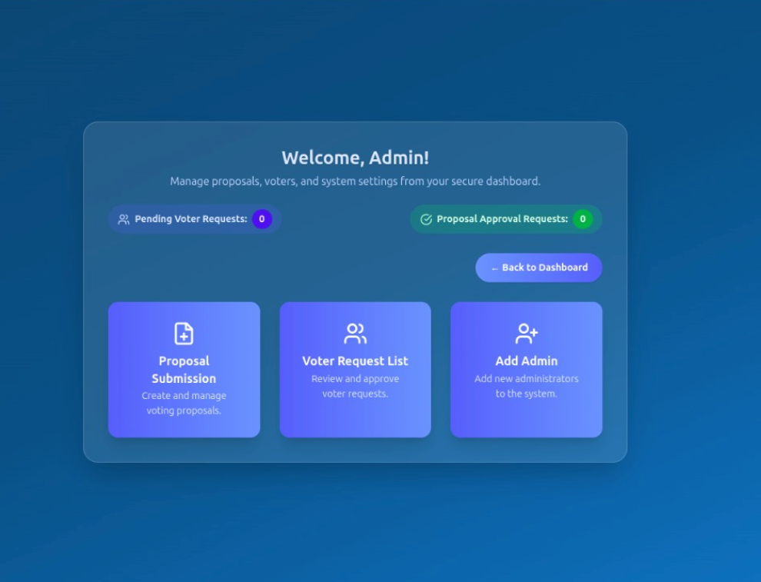

Screenshot of Admin Panel
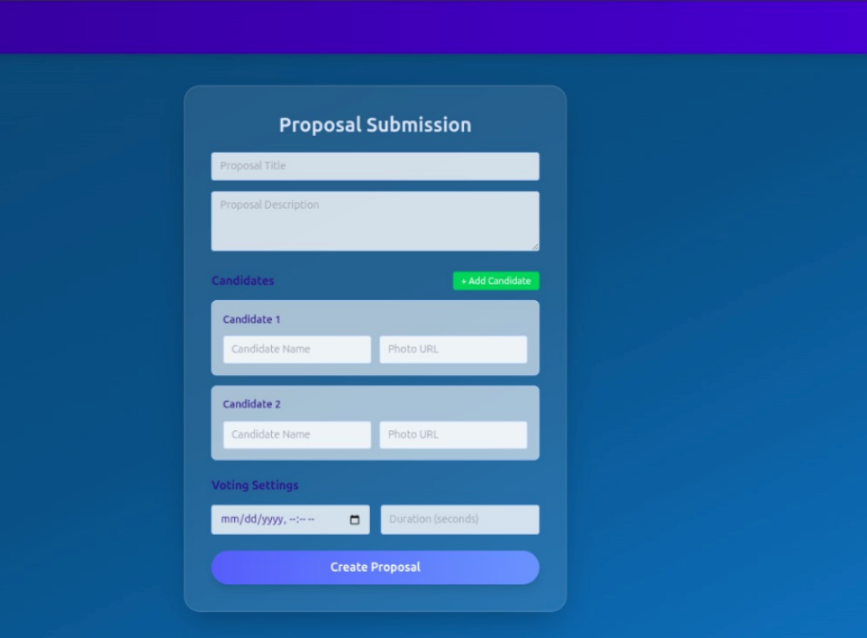

Screenshot of Creating Proposal

